 

**Placement Empowerment Program**

**Cloud Computing and DevOps Centre**

**Host a Static Website Locally**  
**Set up a local server (Apache or Nginx) and host a simple HTML page with your name.**

**Name: Kalairajan S Department: IT**



### **PoC: Hosting a Website Using Apache on Windows**

#### **Step 1: Download Apache**

* Download the latest version of Apache for Windows from [Apache Lounge](https://www.apachelounge.com/download/).
* Extract the downloaded .zip file to C:\Apache24 (or any preferred location without spaces).

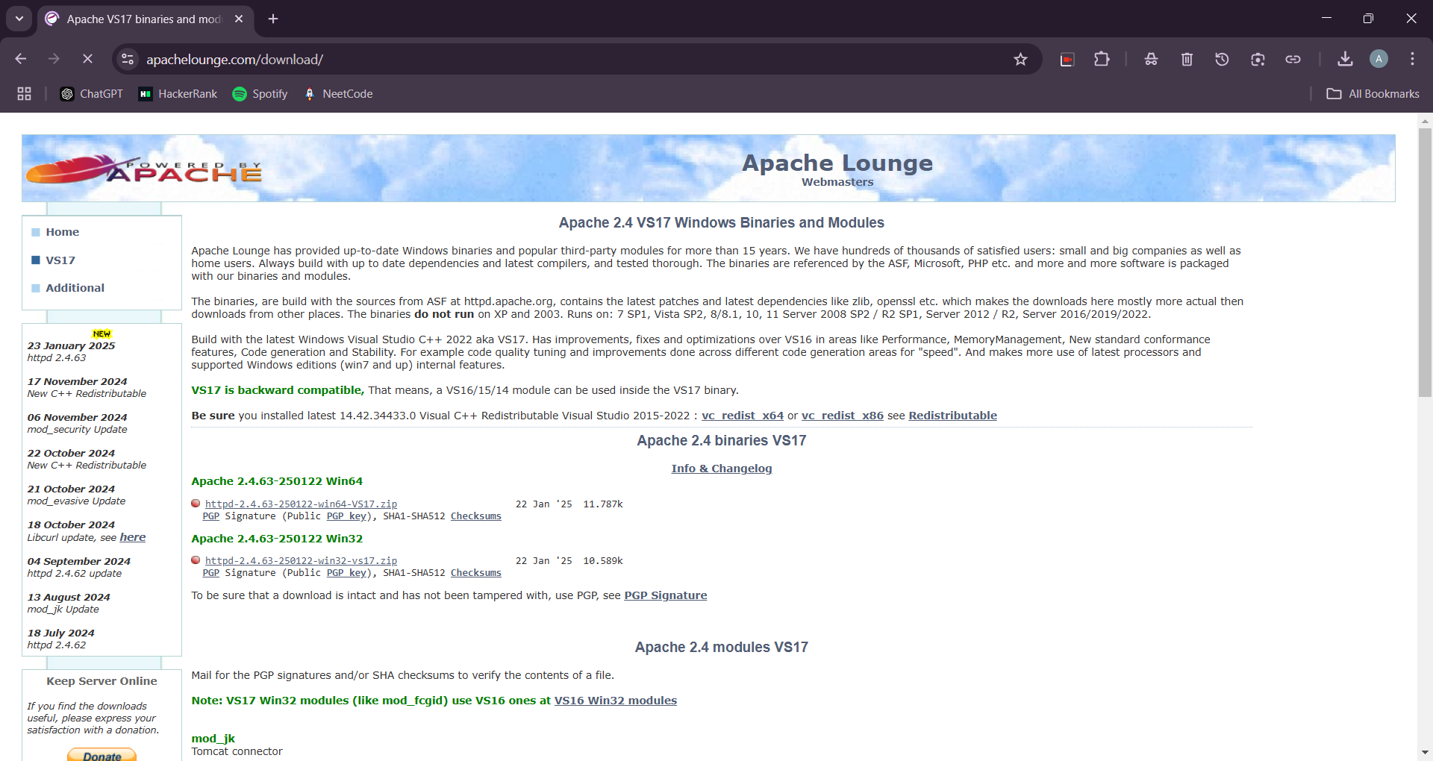

#### **Step 2: Configure Apache**

* Open C:\Apache24\conf\httpd.conf in a text editor.
* Update the following directives:
  + Set the installation directory: ServerRoot "C:/Apache24"

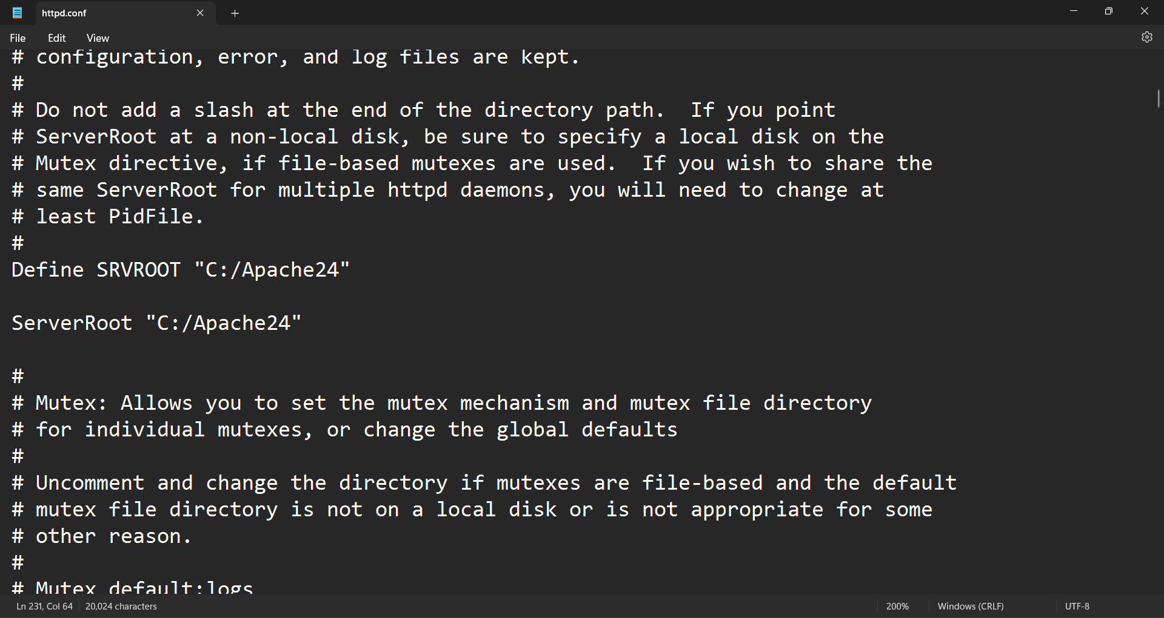

* + Set the website root directory: DocumentRoot "C:/Apache24/htdocs"  
    <Directory "C:/Apache24/htdocs">  
     Options Indexes FollowSymLinks  
     AllowOverride None  
     Require all granted  
    </Directory>

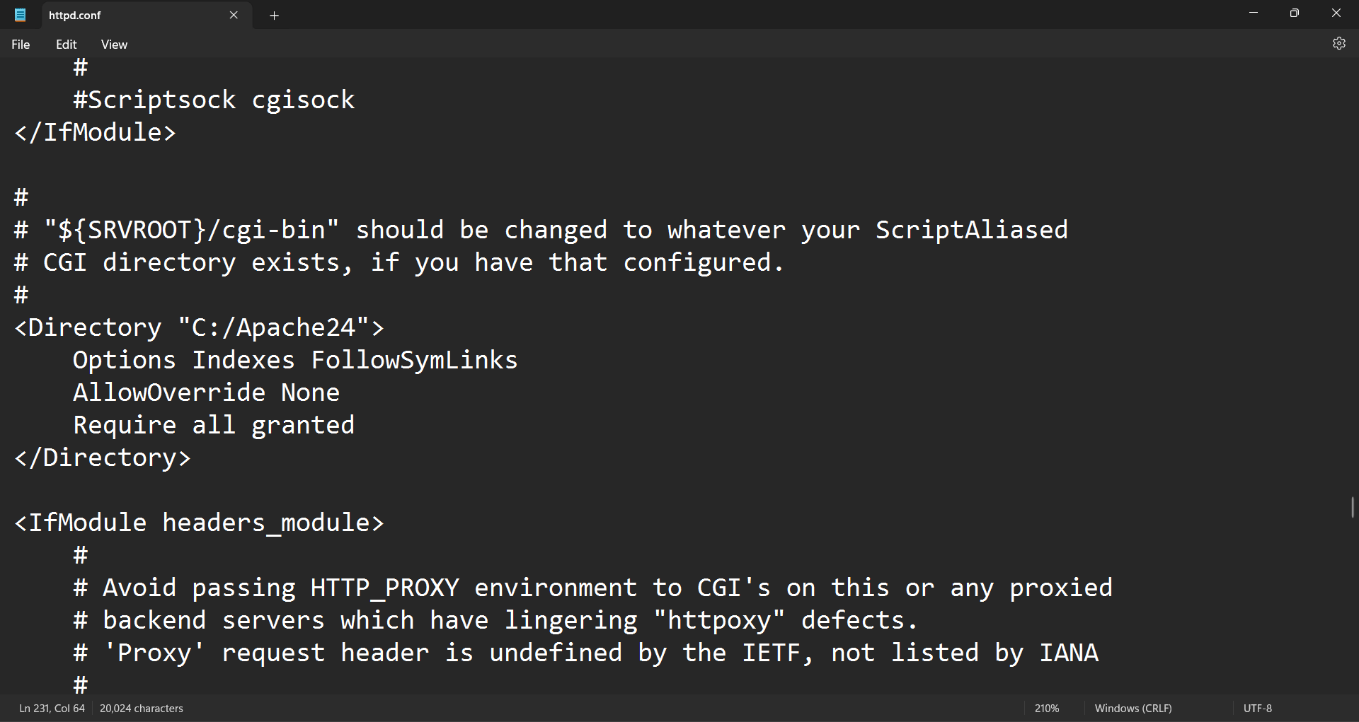

#### **Step 3: Add Apache to the System Path (Optional)**

* Add C:\Apache24\bin to your system’s PATH environment variable. This allows you to run Apache commands from any terminal.

#### **Step 4: Start Apache**

* Open **Command Prompt** as Administrator.
* Navigate to the Apache bin directory and start Apache: cd C:\Apache24\bin  
  httpd.exe

#### **Step 5: Configure Windows Firewall**

* Open **Control Panel > System and Security > Windows Defender Firewall > Allow an app through Windows Firewall**.
* Allow httpd.exe through the firewall for both **private** and **public** networks.

#### **Step 6: Place Your Website Files**

* Copy your website files (HTML, CSS, JavaScript, etc.) to the C:\Apache24\htdocs directory.

#### **Step 7: Test the Website**

* Open a web browser and go to <http://localhost>. Your website should be displayed.

